Haorui Chen - 10407315 - cwk2 - Convolution & Kernels

1. function [res] = cov(img,kernel)

se_len=size(kernel,1);

n_l=floor(se_len/2);

[width,height]=size(img);

% pad to deal wtih edge pixels

I_pad=padarray(img,[n_l,n_l],'both');

% result pic

res=zeros(width,height);

for i=1:width

for j=1:height

% extract subimage filtered by kernel

Block=I_pad(i:i+2*n_l,j:j+2*n_l);

C=Block.*kernel;

% convolution

res(i,j)=sum(sum(C))/sum(sum(abs(kernel)));

end

end

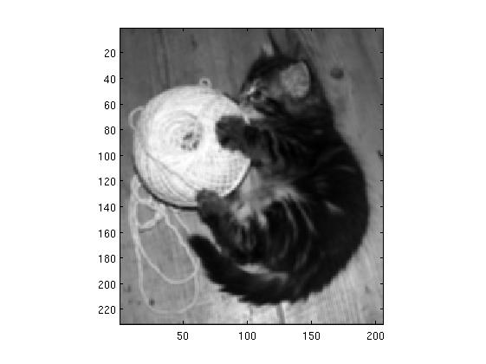 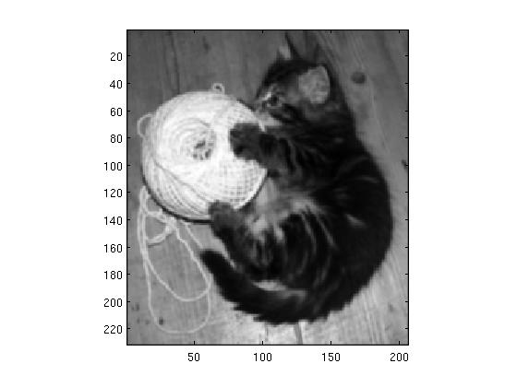

2-1 apply average smoothing kernel 2-2 apply weighted average smoothing kernel



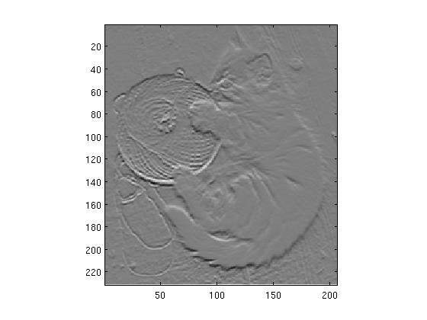 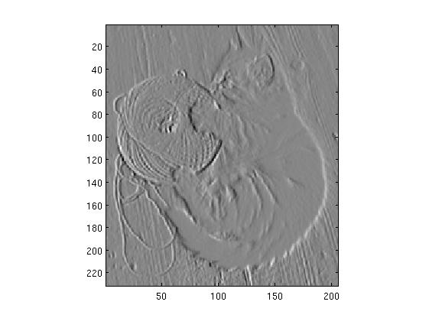

2-1 horizontal edge image 2-2 vertical edge image

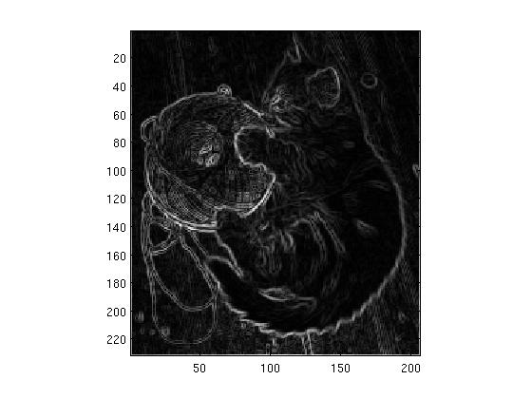

2-3 edge strength image

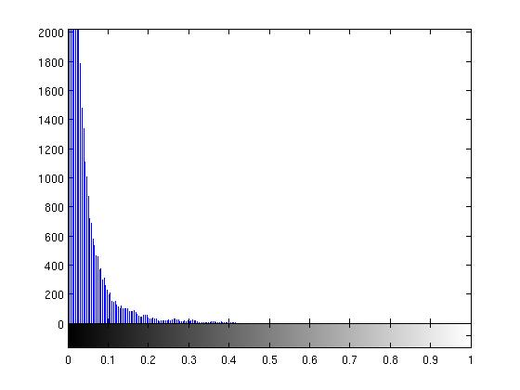

2-4 image histogram of edge strength image

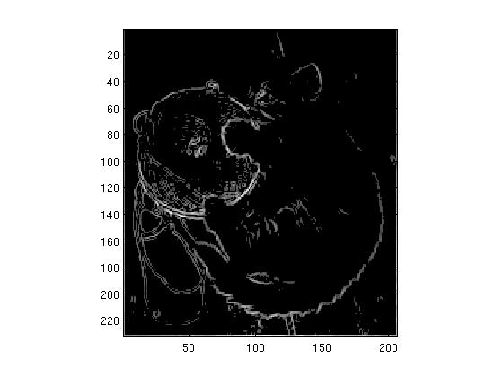 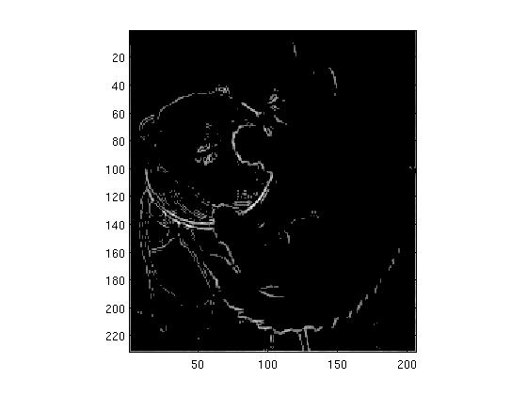

2-5 threshold=0.1 result 2-6 threshold=0.15 result

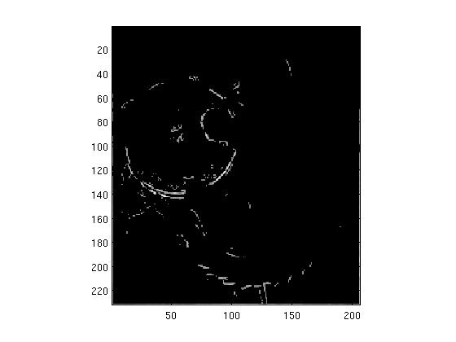 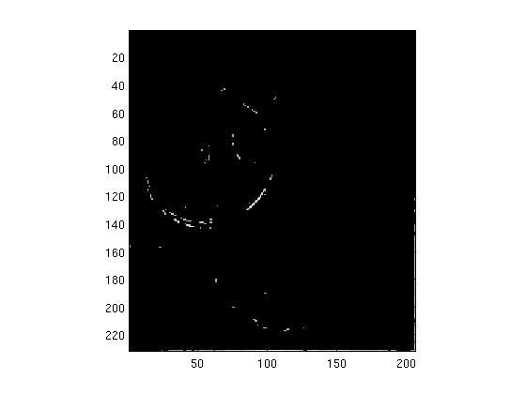

* 1. threshold=0.2 result 2-8 threshold=0.25 result

3.1 Can you ﬁnd a threshold value that gives the edges of the cat, but not the patterns in the fur, or the wood-grain?

Edges of fur and wood grain have similar edge strength with that of the cat, so there is not an ideal threshold that can filter out patterns in the fur or the wood-grain.

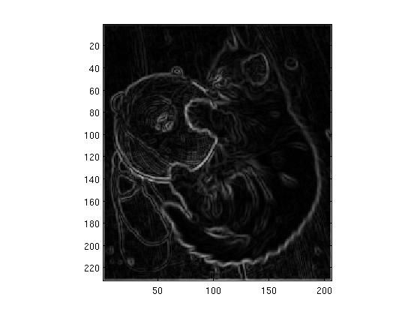

* 1. Edge strength image after applying weighted mean kernel to the image

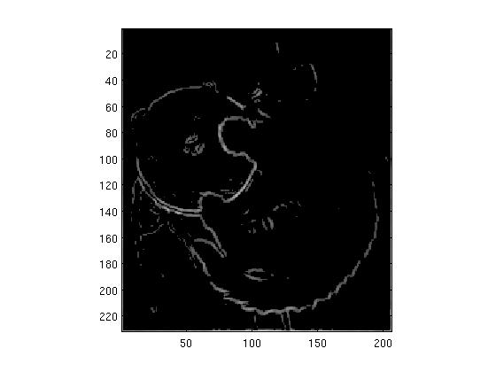 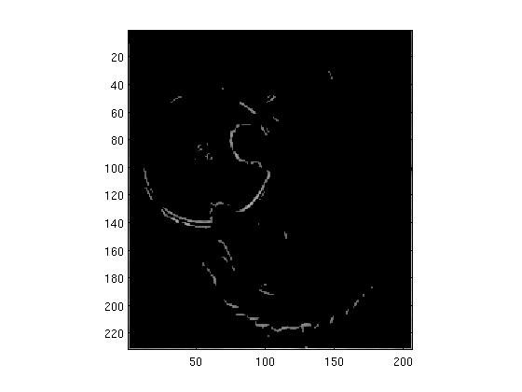

2-10 threshold=0.1 result on blurred image 2-11 threshold=0.15 result on blurred image

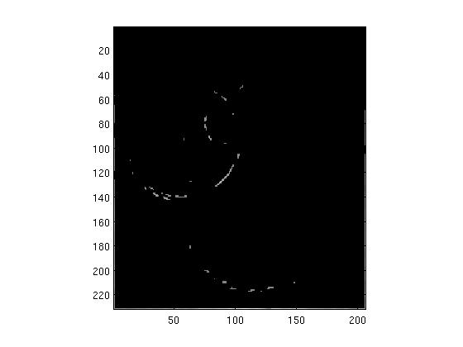

2-12 threshold=0.2 result on blurred image

4.1 What diﬀerence has the weighted-mean smoothing made to the edges detected?

Some minor edges disappeared; detected edges generally get dimmer.